Contact:
Christie Kozak | Leary PR | christie@learypr.com | 978-502-5747

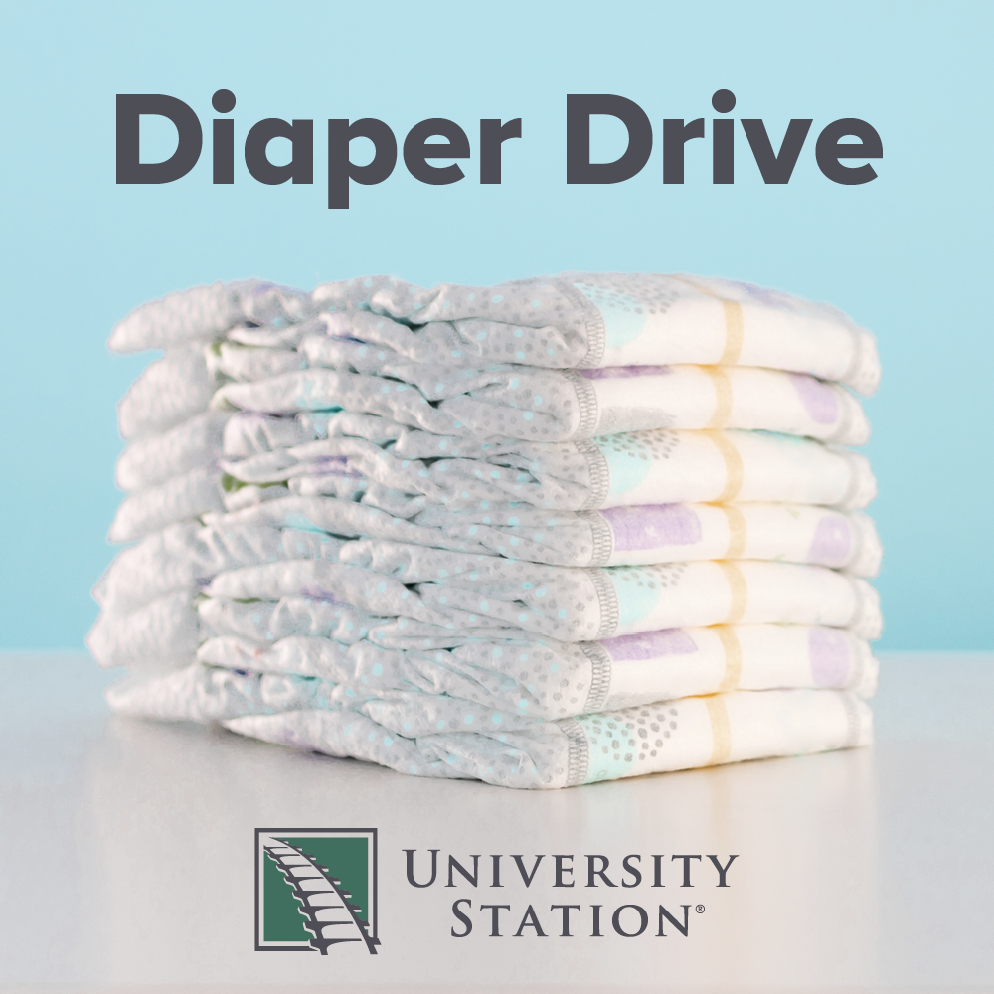

University Station Hosts Diaper Donation Drive
for The Salvation Army of Massachusetts

WESTWOOD, MA (May 2022) - University Station in Westwood (ShopUniversityStation.com) has partnered with The Salvation Army of Massachusetts to host a Diaper Donation Drive. Donations of new baby diapers and baby wipes will be accepted throughout the month of May in the marked bin at Five Below. To make a monetary donation, please visit SalvationArmyMA.org/give.

“The statistics today are staggering with up to one out of every three families finding themselves in diaper need. Your donation of diapers and baby wipes is helping our neighbors who are living in poverty and struggling to buy the essentials for their family,” says Tim Veglas of The Salvation Army Service Extension.

“We are pleased to partner with The Salvation Army on this important diaper donation drive that supports local families in need,” says Rebekah Macchia, Director of Marketing for University Station. For more information, visit ShopUniversityStation.com.

The Salvation Army
The Salvation Army annually helps more than 30 million Americans overcome poverty, addiction, and economic hardships through a range of social services. By providing food for the hungry, emergency relief for disaster survivors, rehabilitation for those suffering from drug and alcohol abuse, and clothing and shelter for people in need, The Salvation Army is doing the most good at 7,600 centers of operation around the country. In the first-ever listing of "America’s Favorite Charities” by The Chronicle of Philanthropy, The Salvation Army ranked as the country’s largest privately funded, direct-service nonprofit. For more information, visit SalvationArmyMA.org. Follow us on Twitter @SalvationArmyMA and #DoingTheMostGood.

University Station
University Station is a vibrant, mixed-used development in Westwood, Massachusetts combining unique retail, restaurant, residential and office uses. Located on University Avenue at Exit 13 on Route 128/I-95, University Station is adjacent to the Route 128 MBTA Commuter Rail/Amtrak Station. Anchored by Target, Wegmans and Nordstrom Rack, University Station features an exciting mix of restaurants and stores including Del Frisco’s Grille, Anthony’s Coal Fired Pizza, Not Your Average Joe’s, Casa Loca Mexican Cantina, Smashburger, Homesense, Michaels, Marshalls/HomeGoods, PetSmart, Ulta Beauty, and Five Below. Courtyard by Marriott®, Life Time Athletic, Brigham & Women’s Health Care Center, Gables Residential (featuring 350 luxury apartments) and Bridges by Epoch (a memory care facility) are also at University Station. For more information, visit ShopUniversityStation.com.

# # #

