**Contact**:

Christie Kozak | Leary PR | [christie@learypr.com](mailto:christie@learypr.com) | 978-502-5747

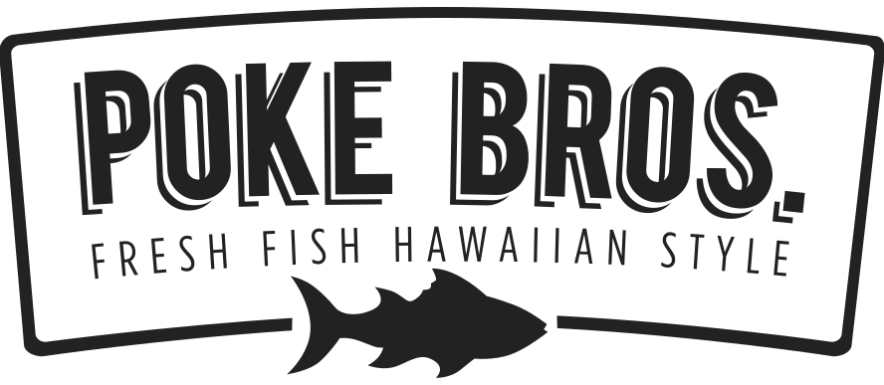

**University Station Welcomes Poke Bros.**

***Featuring Fresh Fish, Hawaiian Style, in a Casual Dining Experience***

WESTWOOD, MASSACHUSETTS (October 2023) – University Station ([ShopUniversityStation.com](http://www.shopuniversitystation.com)) has announced the opening of Poke Bros. The eatery is a fast-casual dining experience that specializes in fresh, Hawaiian-style poké bowls. Poke Bros. offers mouth-watering cubed fish alongside fresh-cut vegetables and traditional flavorings on a bed of steamed rice, creating a poké bowl which is both healthy and tasty.

The Poke Bros. fast casual restaurant concept centers around the familiar assembly line model allowing guests to “build your own” poké bowl with a variety of diverse ingredients. The eatery also offers Signature Bowls as well as lighter snacks including poké nachos, seaweed salad, and refreshing Mochi ice cream.

The three co-founders of Poke Bros. started bringing this island sensation from the California coasts to the Midwest in 2016. “Most fast-food options out there are the same old fried food,” says Poke Bros. founder Xue Gong Chen. “We’re proud that Poke Bros. gives people something that’s quick and easy for lunch or dinner but with fresh, healthy ingredients and great flavor.”

“Poke Bros. is a wonderful addition to our eatery options at University Station. This new dining experience provides a delicious take on the popular Hawaiian dish,” says Rebekah Macchia, Marketing Director for University Station.

**Poke Bros.**

Poke Bros. is headquartered in Columbus, Ohio with over 72 locations across 13 states, including Ohio, South Carolina, North Carolina, Pennsylvania, Florida, Kentucky, New Jersey, New York, Rhode Island, Tennessee, Delaware, Indiana, and Illinois. The restaurant chain first opened its doors in December of 2016 and continues proudly serving up fresh Hawaiian style poké bowls in a convenient, fast casual concept that’s great for lunch, dinner, or a healthy snack. Find out more online at [EatPokeBros.com](http://www.eatpokebros.com/) as well as Facebook, Instagram and Twitter [@eatpokebros](https://www.instagram.com/eatpokebros/).

**University Station**

University Station is a vibrant, mixed-used development in Westwood, Massachusetts combining unique retail, restaurant, residential and office uses. Located on University Avenue at Exit 13 on Route 128/I-95, University Station is adjacent to the Route 128 MBTA Commuter Rail/Amtrak Station. Anchored by Target, Wegmans and Nordstrom Rack, University Station features an exciting mix of restaurants and stores including Del Frisco’s Grille, Anthony’s Coal Fired Pizza, Not Your Average Joe’s, Casa Loca Mexican Cantina, Smashburger, Homesense, Michaels, Marshalls/HomeGoods, PetSmart, Ulta Beauty, Five Below, and J.Crew Factory. Courtyard by Marriott®, Life Time Athletic, Brigham & Women’s Health Care Center, Gables Residential (featuring 350 luxury apartments) and Bridges by Epoch (a memory care facility) are also at University Station. For more information, visit [ShopUniversityStation.com](http://www.ShopUniversityStation.com).

# # #