Contact:
Christie Kozak | Leary PR | christie@learypr.com | 978-502-5747

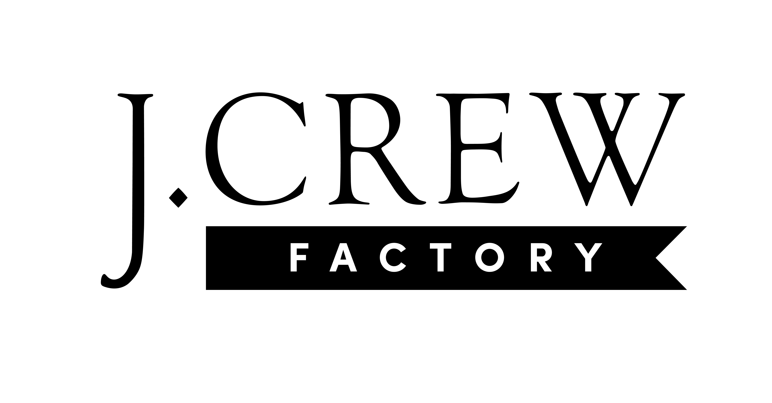
J.Crew Factory Now Open at University Station

WESTWOOD, MASSACHUSETTS (May 25, 2023) – J.Crew Factory is now open at University Station (ShopUniversityStation.com). Known for its fun, classic and colorful styles for women, men, and kids, J.Crew Factory is part of the J.Crew Group family of brands, which is celebrating 40 years (and counting) of elevated American style.

Visitors can celebrate their love of shopping with frequent drops of new arrivals, exclusive in-store-only events, and incredible deals on styles for every occasion. Explore the brand’s very own collection of J.Crew Factory exclusive styles, all at an incredible value. Shoppers will also receive a surprise grand-opening offer when visiting the new store.

“We couldn't be more thrilled to be a part of this community,” says Jody Gietl, head of J.Crew Factory. “We’re looking forward to offering families great styles for every occasion, all at compelling prices.”

Perks are offered through J.Crew Passport, the brand’s free-to-join loyalty program. Members earn points on every purchase, a $5 reward for every 200 points, a birthday surprise, early access to discounts and more. Additional discounts are offered for teachers, college students, health-care workers, first responders and military personnel. The retailer offers petite and extended sizes, more styles, and sales at jcrewfactory.com, where deal seekers can shop online 24/7.

“We are excited to have J.Crew Factory now open at University Station. We know shoppers will enjoy the store’s amazing selection of classic styles for the entire family,” says Rebekah Macchia, Marketing Director for University Station.

About J.Crew Factory
We think shopping should be fun. Actually, really fun. As in scoring our exclusive collection of colorful, classic styles at prices that can’t be beat—period. A fan of timeless silhouettes and amazing fits? We’ve got you. Like mixing in extra-special details, of-the-moment fabrics and prints you won’t find anywhere else? Check. Need to get dressed for your first job interview, a special wedding or an upcoming vacation? You’ve come to the right place. Whatever the occasion, we’ve got great styles for the whole family that’ll have your crew looking good. Plus, we believe that picking up your favorite looks in stores and online shouldn’t mean spending an arm and a leg, so there are always deals waiting for you. We’re talking 24 hours a day, seven days a week. For more information, visit JCrew.com, Madewell.com and JCrewFactory.com.

University Station
University Station is a vibrant, mixed-used development in Westwood, Massachusetts combining unique retail, restaurant, residential and office uses. Located on University Avenue at Exit 13 on Route 128/I-95, University Station is adjacent to the Route 128 MBTA Commuter Rail/Amtrak Station. Anchored by Target, Wegmans and Nordstrom Rack, University Station features an exciting mix of restaurants and stores including Del Frisco’s Grille, Anthony’s Coal Fired Pizza, Not Your Average Joe’s, Casa Loca Mexican Cantina, Smashburger, Homesense, Michaels, Marshalls/HomeGoods, PetSmart, Ulta Beauty, Five Below, and J.Crew Factory. Courtyard by Marriott®, Life Time Athletic, Brigham & Women’s Health Care Center, Gables Residential (featuring 350 luxury apartments) and Bridges by Epoch (a memory care facility) are also at University Station. For more information, visit ShopUniversityStation.com.

# # #

